***UNCOVERING THE GAMING INDUSTRY’S HIDDEN GEMS:***

***A COMPREHENSIVE ANALYSICS OF VIDEO GAMES SALES***

Submitted by

**R.SWETHA**

(Reg.No.12020U25032)

**K.SUBASHINI**

(Rge.No.12020U25028)

**M.SUBASRI**

(Reg.No.12020U25029)

**R.SUMITHA**

(Reg.No.12020U25030)

DEPARTMENT OF

BACHELOR OF SCIENCE IN MATHEMATICS

***KRISHNASAMY COLLEGE OF SCIENCE, ARTS***

***&MANAGEMENT FOR WOMEN - CUDDLORE***

PROJECT CONTENT

1. INTRODUCTION

1.1 Overview

1.2 Purpose

1. PROBLEM DEFINITION & DESIGN THINKING

2.1 Empathy Map

2.2 Ideation & Brainstorming Map

1. RESULT
2. ADVANTAGES & DISADVANTAGES
3. APPLICATIONS
4. CONCLUSION
5. FUTURE SCOPE
6. APPENDIX
7. Source Code
8. **INTRODUCTION**
   1. Overview

Video Games sales analysis is the process of collecting and analyzing data about the sales of video games in order to understand market trends and consumer behaviour. Video Games are released by a publisher like Activision, etc., across different platform. Video games have become a major platform of entertainment especially for kids and is used for business purpose as well. It’s a video games is an electric game that involves interaction with a user interface or input device. The overall gameing experience is the most important thin, although the target at the end of the game can enhance the play. Video game used to pass tie or as an excuse to drink or as a way of demonstrating status, aong other things, are usually simple enough to grasp quickly, or can be played with little concentration over gossip.

* 1. Purpose

This type of analysis can be useful for a variety of purpose, including identifying the most popular games and genres, predicting future sales, and developing marketing strateategies. Video game sales analysis typically involves collecting data from Kaggle sources. This data may include information about the number of units sold, the retail price , and the platforms on which the games are played. Once the data has been collected, it is typically analysed using the video gmes.

The result ofanalysics can be used to identifiy trends and patterns in the market, and to make informed decisions about the development and marketing of video games. It si an important part of the video game industry, as the helps to understand the needs and prefernces of consumers and to identify opportunities for growth and innovation.

**Social impact:** The social consequences of gaming addiction can be devastating. It can be put a huge strain on relationship with family members and friends. Lying about the amount of time spent gaming and neglecting ohers to play video games compulsively can cause confrontationof video games.

1. ***PROBLEM DEFINITION & DESIGN THINKING***

2.1  **Empathy Map**

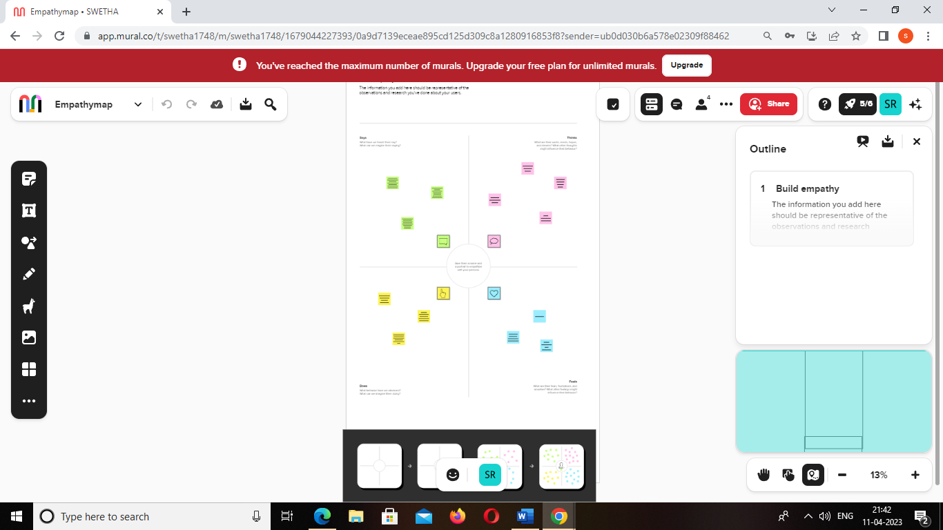

2.2 **Ideation & Brainstorming Map**

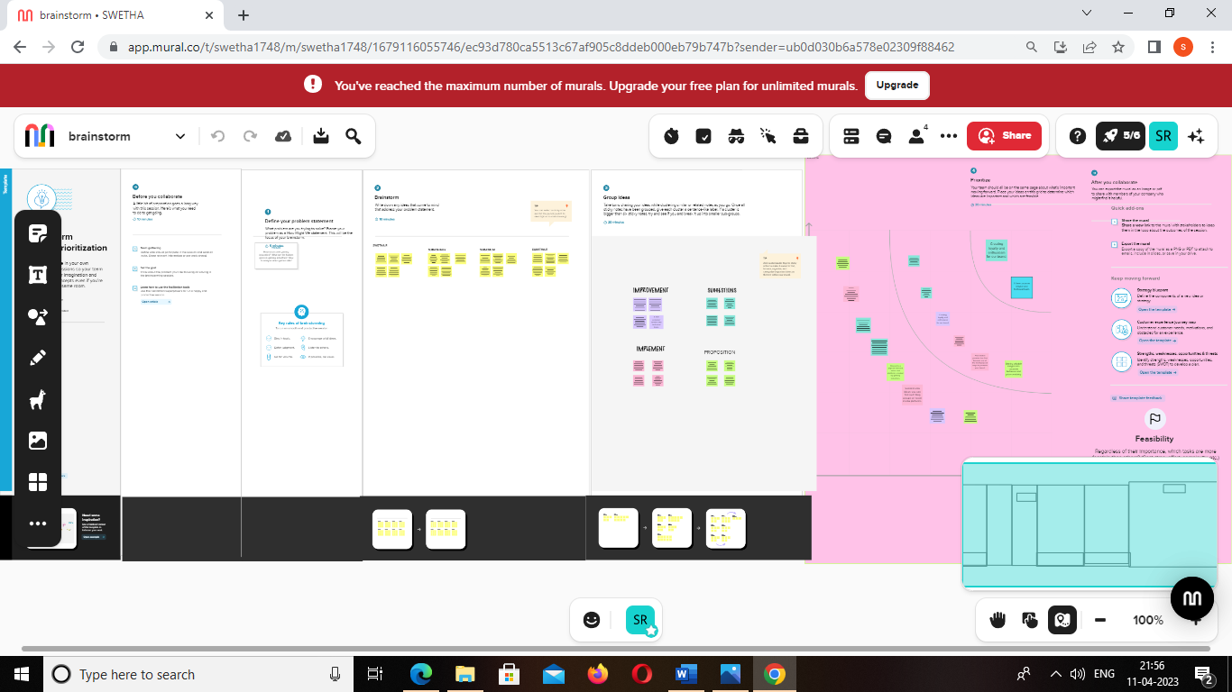

**3.RESULT**

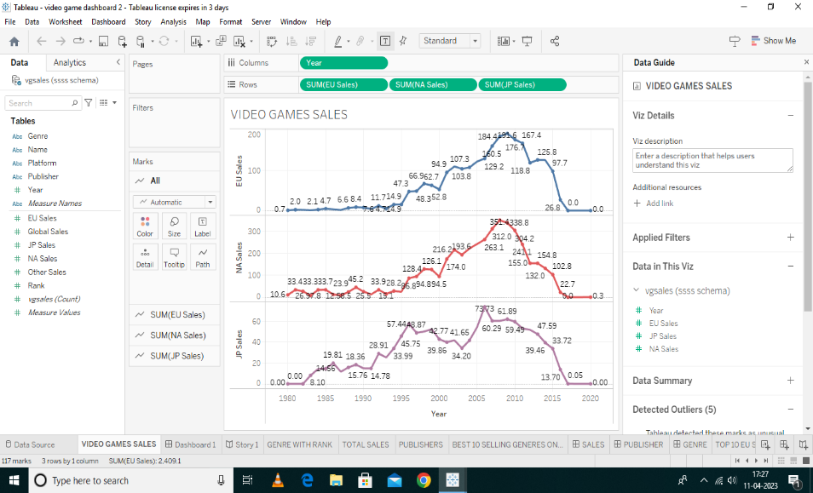



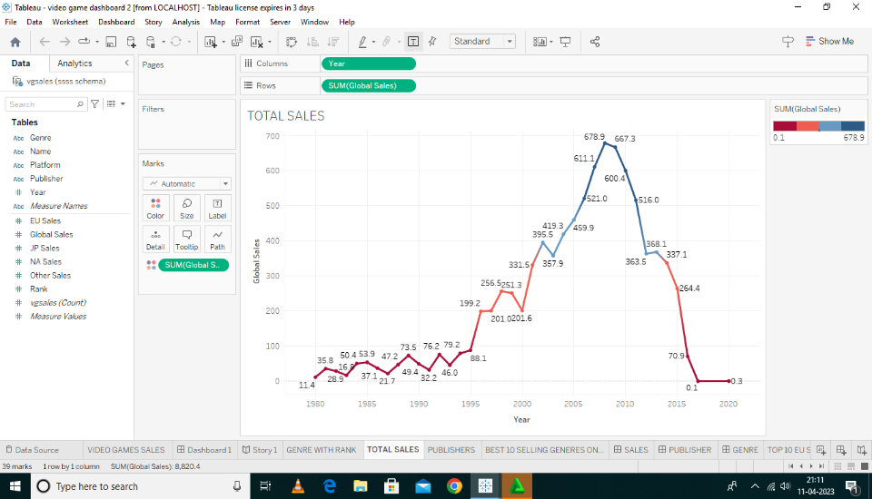









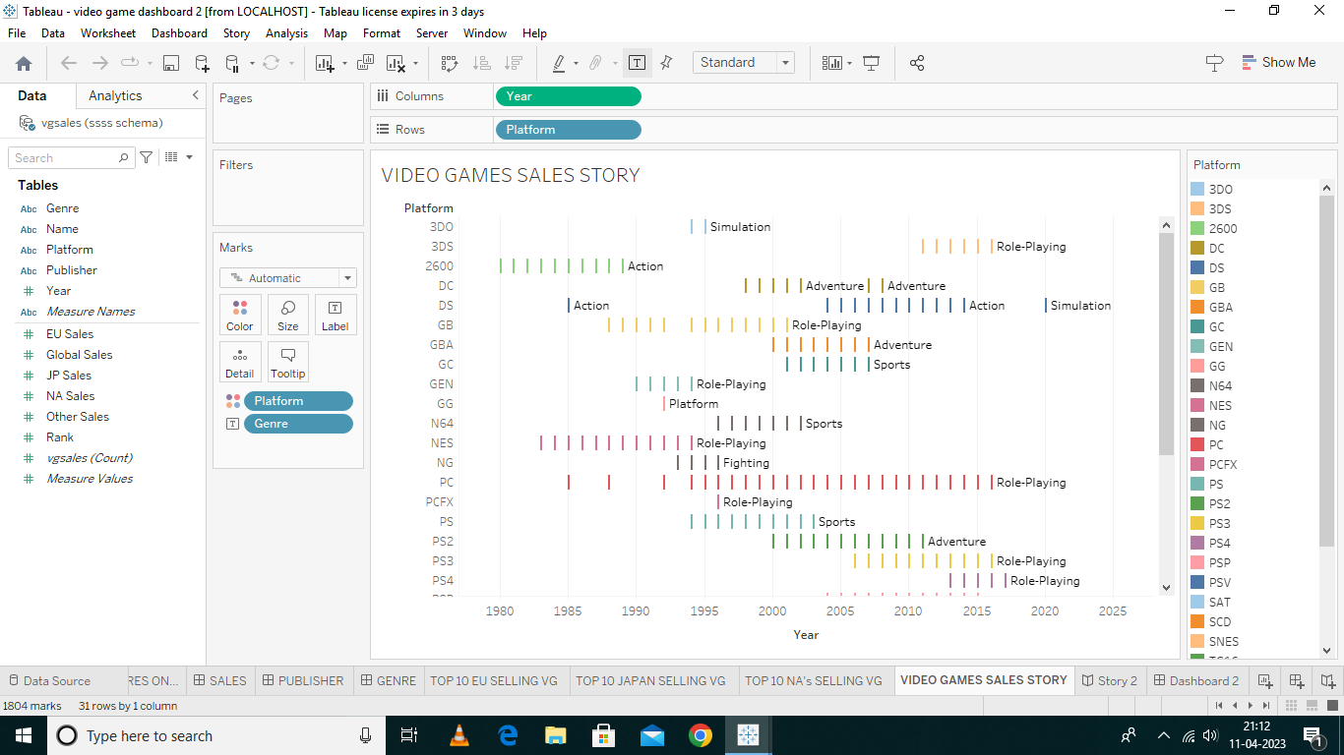



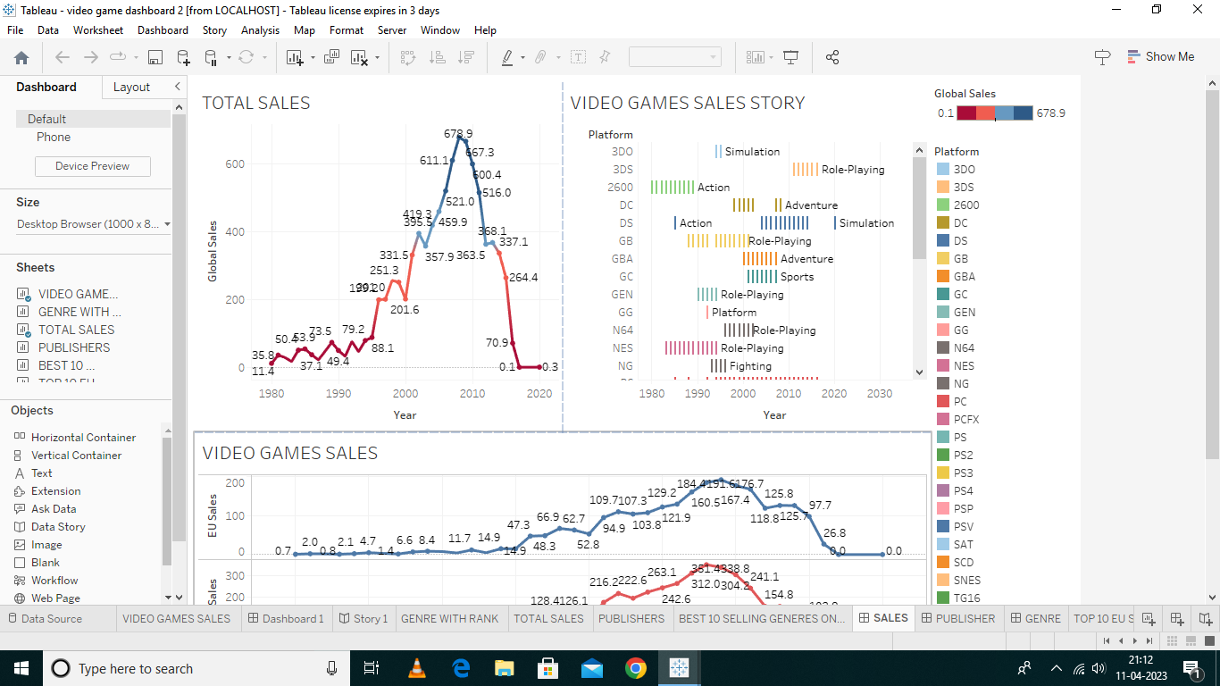



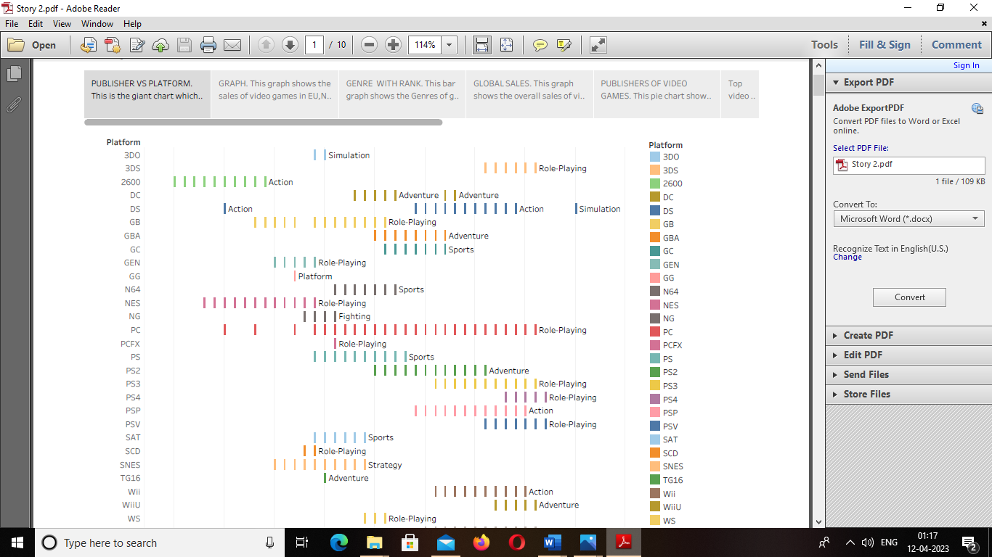

***4 ADVANTAGES & DISADVANTAGES***

**\* ADVANTAGES**

Even though video games are demonized by most non-players, many scientists and psychologists find that video games can have many benefits. Some of them are explained below.

**1. Improved Vision**

Studies suggest that video game players may get an unexpected benefit from them; better vision. They have been shown to increase players’ ability to distinguish subtle differences in shades of gray.

They may also help players increase their ability to visually detect the direction of movement. It was found that gamers spotted targets on a cluttered screen 80% of the time, while non-gamers managed this only 30% of the time.

### 2. Brain Booster

Playing video games directly impacts regions of the brain responsible for memory, spatial orientation, information organizations, and fine motor skills. As people age, the importance of playing games tends to increase.

It could improve decision-making skills; compared to non-players, gamers who spend time daily with fast-paced games can react to questions or situations up to 25% faster.

### 3. Improved Life Skills

Video games involve taking risks, and the ability to strategize. It teaches patience, perseverance, and the right judgment. It also helps people find new friends and social connections. Besides, gamers become better at critical analysis and learn to concentrate on tasks at hand to completion.

### 4. May Ease Anxiety and Depression

It has been found that people are more confident, energetic and emotionally positive when they play video games, which is exactly the opposite of what depression brings about.

People who feel depressed lack physical energy, find it difficult to carry out daily tasks and are generally pessimistic. Thus, playing can reduce the risks for depression, help with arthritis, and even be a therapeutic option for aphasia.

### 5. Painkiller

According to a study from the American Pain Society, video games, and more specifically 3D ones, could help reduce the brain’s response to physical pain.

Playing an attention-grabbing video game may distract one away from a painful activity and help them with chronic pain conditions, especially children.

## **Disadvantages of Video Games**

Video games can teach us high-level thinking skills, but too much of anything can be bad. Some consequences of playing these games are listed below.

### 1. Addiction

Video games are designed to be addictive, so it is essential to have some self-control. Especially people with poor impulse control or who have a hard time fitting in are most vulnerable to game addiction.

It could be because people tend to play games to fill the void that real-world problems leave behind. It is better to watch out for this form of addiction because it might eventually end up costing you a lot.

### 2. Social Replacement

Video games often act as a replacement for real-time human connections. People who find themselves playing hours upon hours of video games may find themselves losing touch with the relationships they’ve built with other people.

People argue that with [internet](https://honestproscons.com/pros-and-cons-of-5g-technology/)-connected games, they can easily hang out with friends and families without ever leaving home, but this type of virtual get together is no replacement for actual face-to-face interaction.

### 3. Obesity

New studies show that the risk of being overweight increases with every hour people spend on virtual play. Lack of motion and overplaying lead to muscle pain as well. Moreover, the addiction to these games leads to sleep deprivation which contributes to obesity.

### 4. Stress

Video game addiction could lead to other levels of psychological stress as well. Gamers may suffer from low self-esteem, have social anxieties, or even suffer from depression.

Excessive gaming can also inspire feelings of guilt and shame. It is possible that uncontrolled gaming could enhance the signs and symptoms of other mental disorders.

### 5. Could Limit Academic Process

Although video games can improve the strategic thinking decision-making process, they can also deteriorate them. Students who use their free time to play video games can struggle to keep up with school/college. Most gamers have been seen to procrastinate on their studying, or they simply ignore a deadline just to play their favorite game.

**5. APPLICATIONS**

In the video game industry encompasses the development, marketing, and monetization of video games. The video games industry lost its innocence a long time ago. These days mature sector, admired for its technological muscle, innovative capacity. This figures don’t lie: the sector will end 2019 with the global income of more than $ 150 billion and year on year growth of 9.6%, according to market intelligence company New zoo.

It breathes life into education: it transform learning into enjoyable, thrilling game a without being lessons. Students assimilate and retain information almost without noticing.

It boosts motivation: Students are the main characters in the story and their success is rewarded with medals, extra lives, bonuses, etc.

The benefits of video games have also reached education with the game-based learning. This teaching method uses beneficial aspects of video games to transmit knowledge to students.

**6.CONCLUSIONS**

Looking at the video games pros and cons it is very much clear that is a very much issue which needs proper addressing. Earlier the negative effects of video game were more evident and published. There is also the possibility of take statistics promoted by the gaming industry to sustain their business. The possibility cannot be ruled not as the profit is large and tempting. Pros and Cons of gaming will always be there and always have been. Research and scientists can also contribute towards this effect by negating the cons of games and utilizing the pros to the max towards productive output and or future.

**7. FUTURE SCOPE OF VIDEO GAMES**

Game Desiging is one of the most upcoming Course for students who wanted to make a Game Designer Career in India in animation. The gaming industry is rapidly growing at a place of 50% per annum. There is a very wide and bright future in game design in India. Studetnts can earn up to 3 Lakh to 5 Lakh PA.

1. **APPENDIX**
2. Source Code

